**LAB 5**

NAME-SAKA SHREYA

ROLLNO-25MML0049

**Step1:** a custom image dataset is created such as mouse, keyboard, glasses, and monitor. The dataset is split into training and testing sets to evaluate the model’s performance.

**Step 2:** Images are resized to 96×96 pixels and processed using the Image block. A Transfer Learning (Images) block is added as the learning block to perform image classification using a pretrained model. The output features represent the four selected object classes.

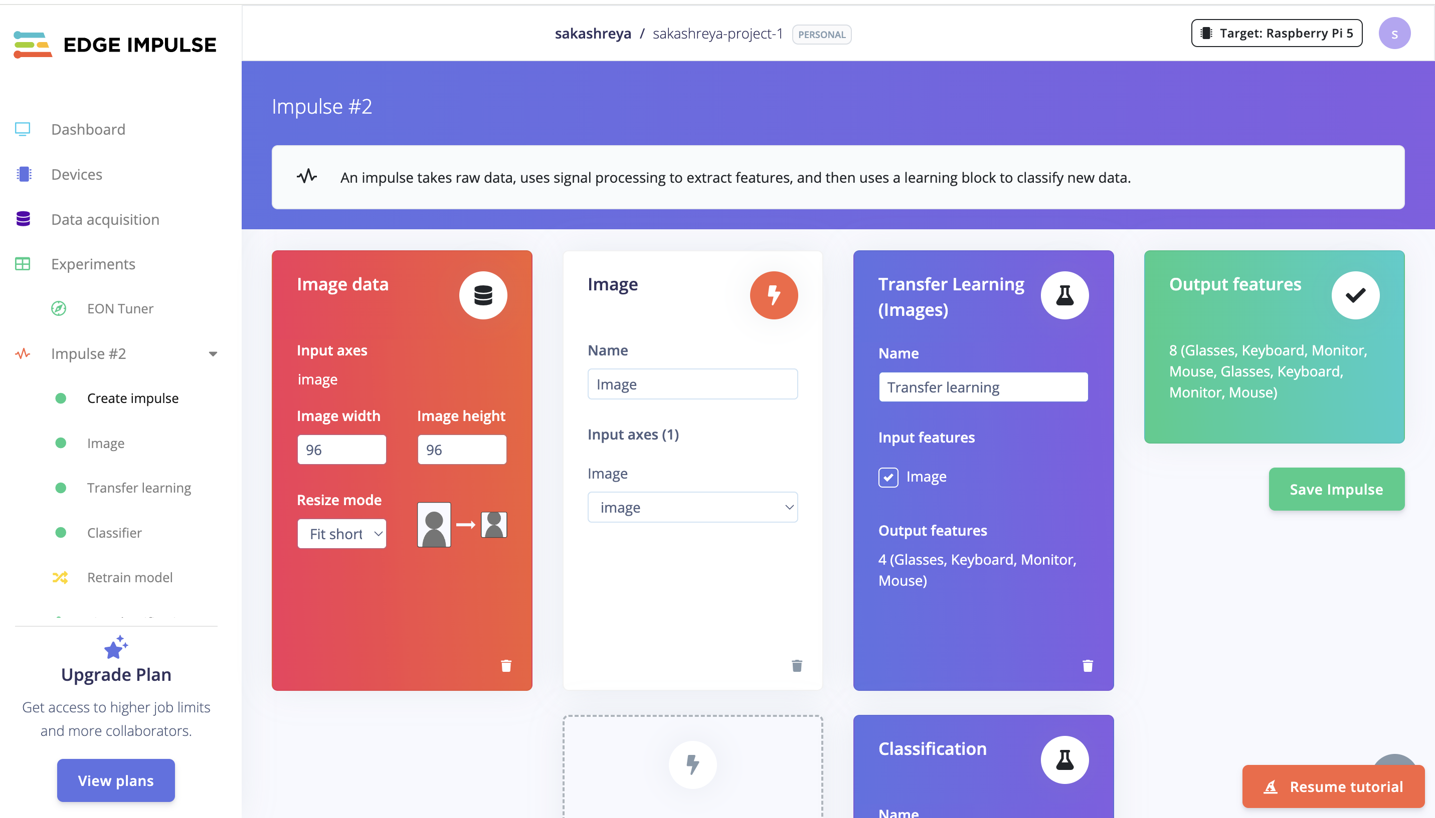

**Step 3:** the Image processing block converts raw images into processed features. The images are normalized and resized, and pixel-level features are extracted.

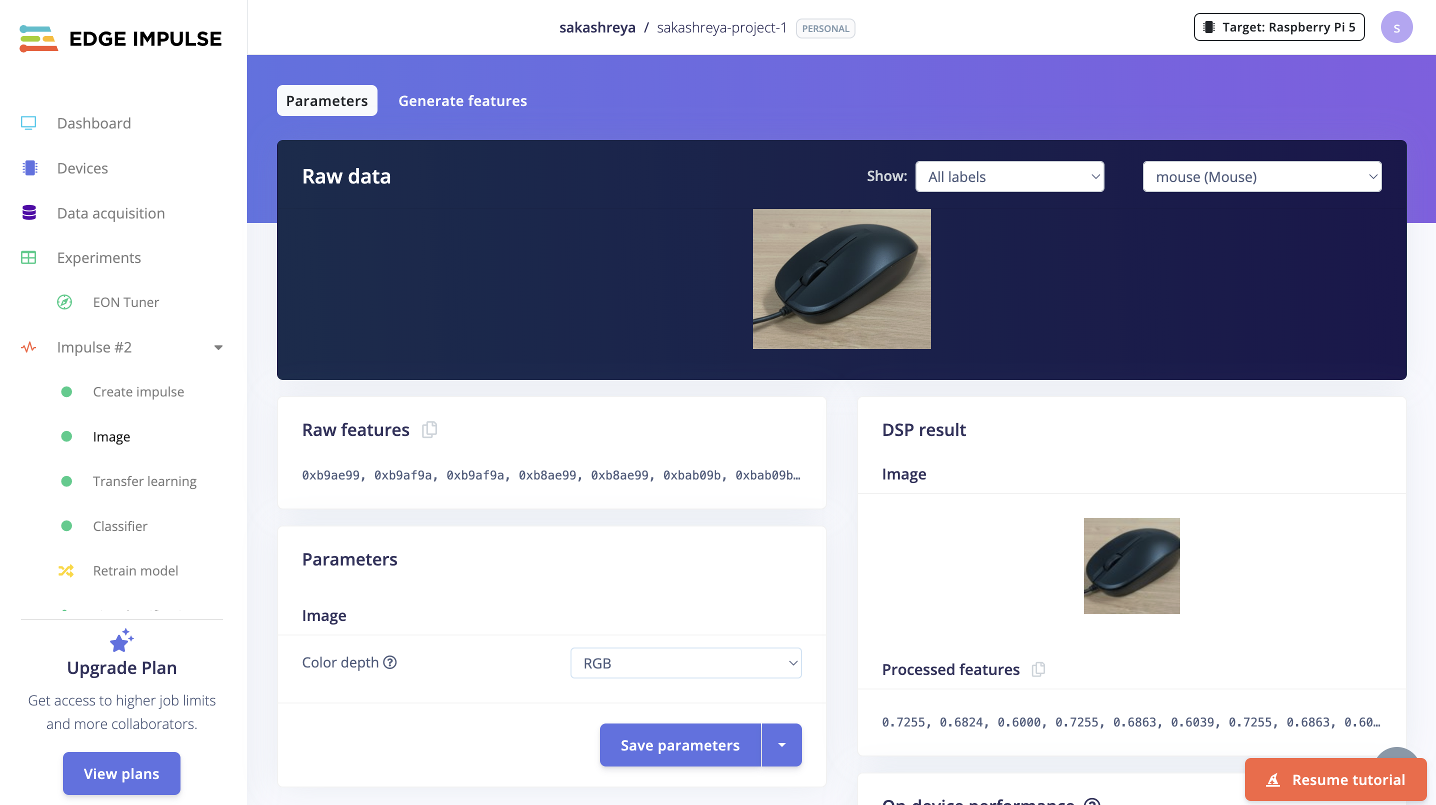

**Step 4:** The model consists of convolution and pooling layers followed by flatten and dropout layers. The network is trained for 120 training cycles using a learned optimizer. After training, the neural network achieved an accuracy of approximately 60%.

Step 5: a transfer learning model based on MobileNetV2 is trained using the same dataset. After training the accuracy is approximately around 40 %.

